CHAPTER TWO

LITERATURE REVIEW

2.1 INTRODUCTION

The healthcare sector is undergoing a transformative shift towards digital solutions to address the challenges of accessibility, efficiency, and quality of care. In this context, online doctor appointment booking systems have emerged as a promising tool to streamline the process of accessing medical services and enhance the patient experience. This literature review aims to explore existing research and developments in the field of online appointment booking systems, with a focus on understanding their impact on healthcare delivery, patient outcomes, and healthcare provider workflow.

The adoption of digital technologies in healthcare has been driven by the need to overcome the limitations of traditional appointment scheduling methods, which are often characterized by inefficiencies, long wait times, and limited accessibility. By enabling patients to book appointments online, these systems offer the potential to reduce administrative burden, optimize resource allocation, and improve patient satisfaction. Moreover, the integration of features such as symptom checking tools holds promise for empowering patients to take a more active role in managing their health and seeking appropriate medical care.

In recent years, a growing body of literature has emerged exploring various aspects of online appointment booking systems, including their usability, effectiveness, and impact on healthcare delivery. Studies have investigated factors influencing patient adoption and satisfaction with these systems, as well as the perspectives of healthcare providers on their integration into clinical practice. Additionally, research has examined the role of online appointment booking systems in improving access to care for underserved populations and reducing disparities in healthcare access.

This literature review will synthesize findings from previous studies to provide insights into the design, implementation, and impact of online appointment booking systems in healthcare settings. By critically evaluating existing research, this review aims to identify gaps in the literature and inform the development of an effective and user-friendly online appointment booking system with an integrated symptoms checker. Ultimately, this research seeks to contribute to the ongoing efforts to harness digital technologies to improve healthcare access, efficiency, and patient outcomes

2.2 EMPIRICAL REVIEW

ZOCDOC

Zocdoc is a highly regarded platform that facilitates healthcare appointment booking and streamlines the patient-doctor connection. Its key functionality includes a user-friendly interface that allows patients to search for healthcare providers based on specialty, location, insurance coverage, and availability. This makes it incredibly convenient for individuals to find the right doctor and schedule appointments efficiently

Moreover, Zocdoc integrates a robust review system where patients can read reviews and ratings of healthcare providers from other patients. This feature enhances transparency and helps patients make informed decisions about their healthcare. Additionally, Zocdoc offers automated appointment reminders, online client booking, and verified client reviews, all of which contribute to a seamless and reliable healthcare experience.

Furthermore, Zocdoc's mobile app provides users with on-the-go access to its services, allowing them to manage appointments, check symptoms, and communicate with healthcare providers conveniently from their smartphones. This mobile accessibility enhances patient engagement and satisfaction, making healthcare management more accessible and efficient.

In conclusion, Zocdoc's comprehensive functionality, including easy appointment booking, provider reviews, appointment reminders, and mobile accessibility, makes it a valuable tool for both patients and healthcare providers, contributing significantly to improving the overall healthcare experience.

DOCTOR ON DEMAND

Doctor On Demand is a leading telemedicine platform that provides convenient access to healthcare services through virtual consultations with licensed medical professionals. One of its key functionalities is the ability to connect patients with doctors, therapists, and specialists remotely, allowing individuals to receive medical advice, prescriptions, and therapy sessions from the comfort of their homes. This feature is particularly beneficial for patients with mobility issues, busy schedules, or those seeking quick medical assistance [1].

Furthermore, Doctor On Demand offers a wide range of medical services, including primary care, mental health counseling, dermatology consultations, and urgent care. Patients can schedule appointments based on their specific healthcare needs, and the platform ensures timely access to medical professionals. Additionally, Doctor On Demand integrates electronic health records (EHR), allowing doctors to access patients' medical histories and provide personalized care [2].

Moreover, Doctor On Demand's user-friendly interface and secure platform make it easy for patients to navigate appointments, view prescription information, and communicate with healthcare providers. The platform also prioritizes patient privacy and data security, complying with HIPAA regulations to safeguard sensitive medical information. Overall, Doctor On Demand's comprehensive functionality and commitment to quality healthcare delivery make it a valuable telemedicine solution for patients seeking convenient and reliable medical consultations

HEALTHTAP

HealthTap is a prominent telehealth platform that offers a wide range of healthcare services through virtual consultations with licensed medical professionals. One of its key functionalities is providing patients with convenient access to doctors, specialists, and therapists, allowing individuals to receive medical advice, prescriptions, and therapy sessions from anywhere, anytime. This feature is particularly beneficial for patients with busy schedules, mobility issues, or those seeking immediate medical assistance [1].

Additionally, HealthTap integrates advanced technologies such as AI-powered symptom checkers and predictive analytics to enhance diagnostic accuracy and treatment recommendations. Patients can use the symptom checker to assess their health concerns and receive personalized recommendations or connect with a healthcare provider for further evaluation. The platform's use of innovative technologies streamlines the healthcare process and improves patient outcomes [2].

Moreover, HealthTap prioritizes patient engagement and education by offering a comprehensive library of medical content, including articles, videos, and wellness tips. Patients can access valuable information about various health topics, medications, and treatment options, empowering them to make informed decisions about their health. Overall, HealthTap's combination of telehealth services, advanced technologies, and patient-centric approach makes it a valuable platform for individuals seeking quality healthcare remotely.

2.2.1 EXISTING SYSTEMS ARCHITECTURES

One application developed to manage patients’ appointment scheduling has used exponential enter arrival times. This model assumes that the exponential enter arrival times could not be directly validated by date, and it is limited due to the nature of the appointment scheduling (Rohleder, 2002). Since appointments are scheduled in the future, the exact model of call arrivals will only have limited impact on measures related to the time between the call and the appointment time. For this reason, the challenge for making appointment system is designing a suitable system based on the health care procedure environment (Klassen, 2002). Hence, the appointment provider in the health care center can schedule a patient into an appropriate time slot on a given day. Klassen (2004) developed another method for managing patients’ appointment using multiple schedule appointment in multiple period environments. Patients can call for any appointment time but if the period time is full, they should replace the appointment to another time. Moreover, various combinations for multi appointment and double booking are measured and recommended for different operational use depending on the health care environment because the varying appointment request has little effect on appointment system performance, especially maintaining acceptable performance, except when the system has the overloaded option (Rohleder, 2004). Many studies about patients’ appointment have found that there are rules or policies for scheduling appointment system such as no scheduling for more than 20 or 30 clients and the best schedule is to place two patients in the first appointment and spread the rest consistently over a period based on average service times (Klassen, 2004). On the other hand, a patient can call for an appointment without knowledge of the type of appointment and appointment queue number and the patient is not aware whether the appointment is variable or not. Sometimes the exact duration for each patient can be known but at other times this is unknown (Rohleder, 2004). Another system developed by Mustafa, (2004) allows a registered patient, having user name and password, to access and explore the list of physicians alphabetically and select a physician whose email contact and profile are also provided. A patient can also view the physician working calendar to find out his/her working and non working day to make an appointment. When the patient selects, view calendar the patient can then choose any valid day in any month to make an appointment (Mustafa, 2004). After that, the patient will receive an e-mail from the system to confirm the appointment time or to inform the patient that the selected time is already taken by another patient or blocked by the physician. In general, the patient appointment system provides all the choices and the capabilities to the patients, such as selecting a physician, selecting the time of appointment, and allows them to access the health care system day or night and schedule their own appointments using the Internet without spending time holding for a nurse or having lengthy phone calls. Wijewickrama and Takakuwa (2005) opine that the health care operating time (due time) is from 8:30 am to 5:30 pm during the week days. Throughout this period, four types of patients arrive to have a consultation appointment in the health care center-appointed patients, same day appointment patients (walk-ins), patients who come for a medical test and new patients (Wijewickrama, 2005). Patients who have appointments are given priority over those who walkin for consultation. Consequently, these latter patients have to wait a long time in the waiting room to meet a doctor even if the consultation time only last few minutes (Takakuwa, 2005). Porta-Sales et al. (2005) developed another system. The main concept of the system is contacting, screening and scheduling appointment with the health care center initially by an expert nurse and the patient initiating contacting with the health care center using the telephone. Moreover, the health care center can be accessible from different places. So there should be PC resources and PC consultations to be accessed from different sources, from other hospitals, from general practitioners, or even from the patients themselves. Porta-Sales et al. (2005) studied 534 patients for a period exceeding one year. After the first visit, 195 patients did not return for the second scheduled appointment and 203 patients had progressed on to the third scheduled visit. The main reason given for the scheduled visits was admission into the health care; the median time-lapse between the first and second visit was 21 days, between the second and third was 27.5 days and between the first and third was 48 days. Comparing patients, who did not attend the three consecutive visits with those who did, indicated that the former had (at the first visit) a lower performance status. Su et al. (2003) studied in a private hospital which has several clinics. For each clinic, the average patient load is 20 per consultation section (morning or afternoon) and the health care system adopts both a patient appointment model and patient registration model. The system allows patients to have self-selected specific physicians for consultation and registration (Shih, 2003). The management appointment system studied by Su and Shih, (2003) is based on the first 20 reserved for scheduled patients, after that, only seven are offered for scheduling. Odd numbers after 20 are left for walk-ins. The arrival time of the first patient is assumed to be the same as the clinic starting time. The scheduled patients are assigned based on 3- main intervals and are also informed about their appointed arrival times (Su, 2003). If the scheduled patient does not appear on time, the next available patient receives consultation immediately. The management operating philosophy of services here is based on “first in, first seen” to limit patient waiting time. Therefore, patients can walk-in to see a physician, when patient shows up at the appointed time (Shih, 2003). Some of the existing appointment booking system have some limitations and the system developed in this research eradicate the limitations of the existing system in confirming patient medical appointment by sending an email to the patient if the appointment have being confirmed or not. It will also enable the patients to view and monitor their medical records online.

2.2.2 PROPOSED SYSTEM ARCHITECTURE

MONOLITHIC ARCHITECTURE

A monolithic architecture would integrate all system functionalities, including appointment booking, symptom checker, EMR, doctor dashboard, and notification system, into a single application. This approach simplifies development and deployment as all components are tightly coupled and managed within the same codebase. However, scaling and maintenance can become challenging as the system grows due to its centralized nature. To adapt this architecture using PHP HTML for the frontend, you can employ Python with Flask or Django for the backend development. MySQL would serve as the database, providing data storage and retrieval functionalities.

The advantages of a monolithic architecture include:

1. Easy deployment – One executable file or directory makes deployment easier.When an application is built with one code base, it is easier to develop.
2. Performance – In a centralized code base and repository, one API can often perform the same function that numerous APIs perform with microservices.
3. Simplified testing – Since a monolithic application is a single, centralized unit, end-to-end testing can be performed faster than with a distributed application.   
   Easy debugging – With all code located in one place, it’s easier to follow a request and find an issue.

The disadvantages of a monolith include:

1. Slower development speed – A large, monolithic application makes development more complex and slower.
2. Scalability – You can’t scale individual components.
3. Reliability – If there’s an error in any module, it could affect the entire application’s availability.
4. Barrier to technology adoption – Any changes in the framework or language affects the entire application, making changes often expensive and time-consuming.
5. Lack of flexibility – A monolith is constrained by the technologies already used in the monolith.
6. Deployment – A small change to a monolithic application requires the redeployment of the entire monolith.

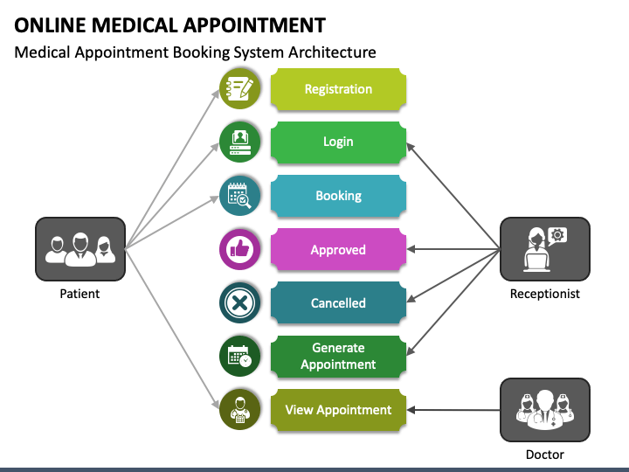

**Microservices Architecture**:

A microservices architecture would split the system into smaller, independent services, each responsible for specific functionalities. For instance, there could be separate microservices for appointment scheduling, symptom checking, EMR management, and notifications. This approach enhances scalability, flexibility, and fault isolation, allowing for easier updates and maintenance of individual components. Technologies like Node.js, Flask, or Spring Boot for microservice development, MongoDB or MySQL for databases, and RESTful APIs for communication between microservices would be suitable

the advantages of microservices are:

1. **Agility** – Promote agile ways of working with small teams that deploy frequently.
2. **Flexible scaling** – If a microservice reaches its load capacity, new instances of that service can rapidly be deployed to the accompanying cluster to help relieve pressure. We are now multi-tenant and stateless with customers spread across multiple instances. Now we can support much larger instance sizes.
3. **Continuous deployment** – We now have frequent and faster release cycles. Before we would push out updates once a week and now we can do so about two to three times a day.
4. **Highly maintainable and testable** – Teams can experiment with new features and roll back if something doesn’t work. This makes it easier to update code and accelerates time-to-market for new features. Plus, it is easy to isolate and fix faults and bugs in individual services.
5. **Independently deployable** – Since microservices are individual units they allow for fast and easy independent deployment of individual features.

 disadvantages of microservices can include:

1. **Development sprawl** – Microservices add more complexity compared to a monolith architecture, since there are more services in more places created by multiple teams. If development sprawl isn’t properly managed, it results in slower development speed and poor operational performance.
2. **Exponential infrastructure costs** – Each new microservice can have its own cost for test suite, deployment playbooks, hosting infrastructure, monitoring tools, and more.
3. **Added organizational overhead** – Teams need to add another level of communication and collaboration to coordinate updates and interfaces.
4. **Debugging challenges** – Each microservice has its own set of logs, which makes debugging more complicated. Plus, a single business process can run across multiple machines, further complicating debugging.

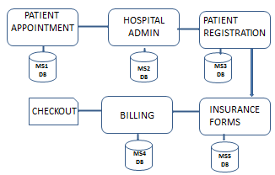

2.3 SYSTEM DEVELOPMENT REQUIREMENTS.

Table: 2.0 Hardware Requirements

In the hardware option the following will be required;

|  |  |  |
| --- | --- | --- |
| **Name of the hardware** | **Quantity** | **Specification** |
| Laptop | 1 | HP |
| Printer | 1 | Laser printer |
| Projector | 1 | Acer |

Table: 2.1 Software Requirements

In the Software option the following will be required;

|  |  |  |
| --- | --- | --- |
| **Name of the software** | **Quantity** | **Specification** |
| IDE | 1 | Visual studio |
| Microsoft office | 1 | Ms. word |
| Database system | 1 | MySQL |
| Antivirus | 1 | SMADAV |
| Operating system | 1 | Window saver OS |
| Operating system | 1 | Window workstation OS |

CHAPTER THREE

SYSTEM DEVELOPMENT METHODOLOGY

3.1 INTRODUCTION

The system development methodology refers to the approach used to plan, design, develop, test, deploy, and maintain the system. It provides a structured framework to ensure efficient and successful system development. Common methodologies include Agile, Waterfall, and Iterative methodologies. The choice of methodology depends on factors such as project scope, timeline, team size, and flexibility requirements. The selected methodology should promote collaboration, and adaptability to changing requirements, and deliver a high-quality and user-centric doctors appointment and symptom checker system.

3.2 SYSTEM DEVELOPMENT MODEL

Waterfall methodology works well when the project requirements are clear, stable, and unlikely to change significantly during the development process. This allows for a linear progression through the different stages of the waterfall model, including requirements gathering, design, implementation, testing, and deployment.

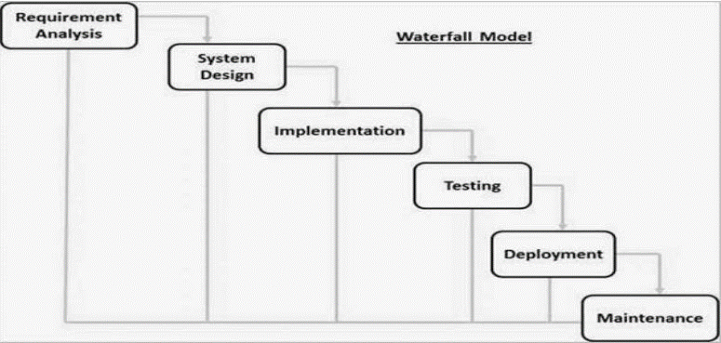

3.2.1Reasons for using Waterfall Design Methodology

Sequential and linear approach: The waterfall methodology follows a sequential and linear approach, where each stage is completed before moving on to the next. This can be beneficial when there is a need for clear milestones and documentation at each stage.

Due to resource and time constraints: In our case the resources and time were limited. The waterfall methodology allows for upfront planning and estimation, enabling better resource and time allocation.

Regulatory and compliance requirements: Due to the stringent regulatory and compliance requirements in the food and restaurant industry it was suitable to use the waterfall methodology. The upfront planning and documentation in each stage help ensure that all necessary compliance standards are met and properly documented.

Well-established processes and methodologies: Due to the pre-determined processes and functionalities of the system a well-structured methodology was the right choice.

3.2.2 Advantages of the Waterfall Model:

Clear and Structured Process: The waterfall model follows a well-defined, sequential, and systematic approach.

Easy to Understand and Use: The model is easy to understand and use. The process follows a linear and sequential approach that is easy to comprehend.

Efficient Document Management: The model relies heavily on documentation. Thus, it ensures efficient document management, which is critical for software development.

Prevents Scope Creep: The Waterfall model emphasizes defining the scope of the project upfront. It prevents scope creep, which could cause delays and additional costs.

Clearly Defined Deliverables: The model provides well-defined deliverables at each stage, ensuring that the project objectives are met on time and within budget.

3.2.3 Disadvantages of the Waterfall Model:

Inflexible: The Waterfall model is inflexible and does not accommodate changes easily. Getting changes implemented is time-consuming and costly.

No Early Working Model: The Waterfall model does not produce any early working model until the system is complete in all stages or phases.

High Risk: Once a phase of the Waterfall model is completed, it cannot be revisited. This makes the model risky as the software’s usability is only determined at the end of the project.

Limited Customer Input: The Waterfall model does not allow for much customer input. This could lead to delivering a product that does not satisfy customer needs.

Not Suitable for Large Projects: The Waterfall model is not suitable for large projects as they require a flexible approach to accommodate changes. The inflexibility of the model could lead to delays and added costs.

3.3 FACT FINDING TECHNIQUES

1. Survey:
   * Description: Surveys involve collecting data by asking specific questions from a targeted group of participants. You can create questionnaires or conduct online polls to gather information.
   * Advantages:
     + Cost-Effective: Surveys are relatively inexpensive to administer, especially when conducted online.
     + Scalability: You can reach a large number of participants quickly.
     + Quantitative Data: Surveys provide structured, quantifiable data.
   * Disadvantages:
     + Limited Depth: Surveys may not capture detailed insights or nuances.
     + Response Bias: Participants’ responses can be influenced by question wording or context.
     + Limited Generalizability: Findings may not apply universally due to specific demographics or sampling bias.

Example: Creating an online survey asking patients about their preferences for appointment scheduling and symptom checking features.

1. Interviews:
   * Description: Interviews involve one-on-one interactions with stakeholders (such as doctors, patients, and hospital staff). It can conduct structured or semi-structured interviews.
   * Advantages:
     + In-Depth Insights: Interviews allow for detailed exploration of participants’ experiences, needs, and expectations.
     + Flexibility: You can adapt questions based on individual responses.
     + Qualitative Data: Interviews provide rich qualitative data.
   * Disadvantages:
     + Time-Consuming: Interviews require more time compared to surveys.
     + Interviewer Bias: Interviewers’ presence can influence responses.
     + Limited Generalizability: Findings may not represent the entire population.

Example: Interview hospital administrators to understand their requirements for the appointment system.

1. Observation:
   * Description: Observations involve directly watching and recording processes, workflows, and interactions in the hospital.
   * Advantages:
     + Contextual Understanding: Observations provide insights into actual practices and challenges.
     + Workflow Analysis: Identify bottlenecks and inefficiencies.
     + User-Centered Design: Aligns with user needs.
   * Disadvantages:
     + Resource-Intensive: Observations can be time-consuming.
     + Access and Permissions: Gaining access to hospital settings may be challenging.
     + Observer Bias: Researchers’ presence may affect behavior.

Example: Observe the current appointment scheduling process at Medicare hospitals to identify pain points and workflow issues.

3.4 FEASIBILITY STUDIES

Technical Study

1. System Requirements: Define the technical requirements for the appointment booking system, symptom checker, database management, security protocols, and user interface design.
2. Scalability and Performance: Evaluate the system's scalability to handle increasing user loads, ensure fast response times, and maintain data accuracy and integrity.
3. Integration Capability: Assess the system's ability to integrate with external APIs, payment gateways, EMR systems, and other healthcare IT infrastructure.

Financial Study

1. Cost Analysis: Determine the costs involved in system development, maintenance, marketing, and operations, including infrastructure, software development, and personnel.
2. Revenue Streams: Identify potential revenue streams such as consultation fees, premium services, partnerships with healthcare providers, and advertising opportunities.
3. Return on Investment (ROI): Calculate the expected ROI based on projected expenses and revenues over a specific period, considering market growth and competition.

Operational Study

1. Workflow Analysis: Examine the operational processes involved in appointment scheduling, symptom assessment, doctor-patient interactions, and data management.
2. Resource Allocation: Determine the human and technological resources required for system implementation, training, maintenance, and customer support.
3. Workflow Efficiency: Identify potential bottlenecks, streamline workflows, and optimize resource utilization for seamless operations.

Market Study

1. Demand Analysis: Assess the demand for online doctor appointment systems with symptom checkers among patients, considering factors like convenience and accessibility.
2. Competitor Analysis: Evaluate existing platforms offering similar services, analyze their strengths, weaknesses, and market share to identify opportunities and threats.
3. User Base Potential: Estimate the potential user base, considering demographics, healthcare needs, and technological adoption rates.

Legal Study

1. Regulatory Compliance: Ensure compliance with healthcare regulations, data protection laws (e.g., HIPAA), medical ethics, and patient confidentiality standards.
2. Licensing and Certification: Obtain necessary licenses and certifications for offering healthcare services online, including accreditation for medical professionals and liability coverage